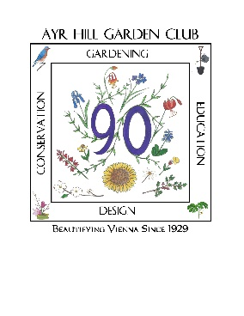
2021 Greener Vienna Grant Program
Sponsored by Ayr Hill Garden Club

In celebration of the 90th anniversary of Ayr Hill Garden Club’s founding mission to create and maintain Beauty in the Vienna community, the Club, in 2019, has created the Greener Vienna Grant Program. In addition to funds, we will make our experience and resources with native Virginia plants available. Gardening groups in our neighborhood serving the public through both old and new gardens are eligible. The aim of the group seeking a grant should be to encourage use of native plants and trees in public gardens throughout Vienna.
Grants of up to $300 will be awarded for direct expenses of the native plant project. The amount of an award would be based on the size and scope of the project as well as the number of awards granted. Awards may be used, in some portion, as credit toward the purchase of native plants at the annual Ayr Hill Garden Club plant sale in May 2022, and if eligible, to apply for matching plant materials from Earth Sangha’s Plant Grant.
Eligibility
To be eligible for the Greener Vienna grant, the applicant must be a non-profit organization such as a school, club, church, scout troop, etc. planning to garden in the Greater Vienna area (22180-2 area codes.)
Application Deadlines
Application period opens May 1, 2021. Complete applications must be emailed to monica.anschel@hotmail.com by September 1, 2021. Grant awards will be announced on October 1, 2021. Projects must be completed by July 1, 2022.

Evaluation Criteria
The Ayr Hill Grant Committee will select grantee(s) based on the criteria below. All decisions are final.
- Impact/benefit of project 30 points
- Use of Virginia native plants 25 points
- Sustainability after completion 25 points
- Visibility to general public 15 points
- Collaboration with other community groups 5 points
Application Requirements
Name and size of applying organization
Contact name with address, email and phone
Project description (one to two paragraphs)
Project timeline
Amount requested, itemized budget of direct expenses and additional sources of funding
Photographs of proposed location before project implementation
Number of members directly participating in the project and description of participation by other community groups
Five year plan for maintenance of the completed project
Whether Ayr Hill Garden Club mentoring support will be needed and in what capacity

Applications should be no more than two pages of text (11 point font or larger with a minimum of ½ inch margins) including photos. Ayr Hill Garden Club Grant Committee will require a final report documenting gardening activities including photographs by July 1, 2021.

